# Using PowerBI for UPMS Reports

## Reports available

|  |  |
| --- | --- |
| Report name | Includes |
| Programme List | Faculty, School, Title, Code, Version, Level, Type, Full time duration, Part-time duration, Awarding Institution, Teaching institution, Accrediting bodies |
| Programme Structure | Faculty, School, Title, Code, Version, Stage (year 1,2 etc), List headers, Unit Code/name, Status (mandatory/optional), Credit points, Is running next year and Sequence |
| Programme Stage Info | Faculty, School, Title, Code, Version, Stage version, Stage notes, Progression notes, Stage exit award (non-final year) |
| All Unit Data | Faculty, School, Code, Title, Level, Credit points, Teaching Block, Director, version, Pre-reqs, Co-reqs, Anti-reqs, Open unit status, Description, ILOs, Assessment info, Teaching info |
| Basic Unit Data | Start year, Faculty, School, Code, Title, Level, Credit points, Teaching Block, Director, Director email, Version |
| Unit Evaluation | Start year, Faculty, School, Code, Title, Level, Credit points, Teaching Block, Director, Director email, Version, Open unit status, Approval status, Hidden status, Mid-year survey exempt, End-year survey exempt, Exemption reason, |
| Unit Counts | By credit points, level, start year, running status, teaching block |
| Current Proposals Not Yet Submitted | Faculty, School, Proposal name, Reference, Proposal date, Proposer, Number of items, Number of programmes, Number of units, Number of shared lists |
| Proposals in workflow (i.e. submitted) | Workflow state, Workflow submission date, Who submitted, Proposal name, Reference, Date of submission, Content type, Content code, If content new |
| Approved changes | Committee type, Faculty, Committee name, Content type, Content code, If new, Credit points (if applicable), Level, Workflow completion date, AY Workflow completed, Proposal name, Proposal reference |

## How to open a Power BI report?

The [Power BI App](https://app.powerbi.com/home?experience=power-bi) provides a single dashboard for ALL Power BI reports, and to interrogate unit and programme information you need to navigate to the [UPMS Reporting section](https://app.powerbi.com/groups/me/apps/9f8a3a39-8743-406d-8cbe-5915cca60502/reports/4460daea-49be-4fb2-bcd0-46a86d0d90a6?experience=power-bi).

## Viewing a Report using the Power BI App

Open the Power BI App, as described above, and the App display is composed of two main areas:

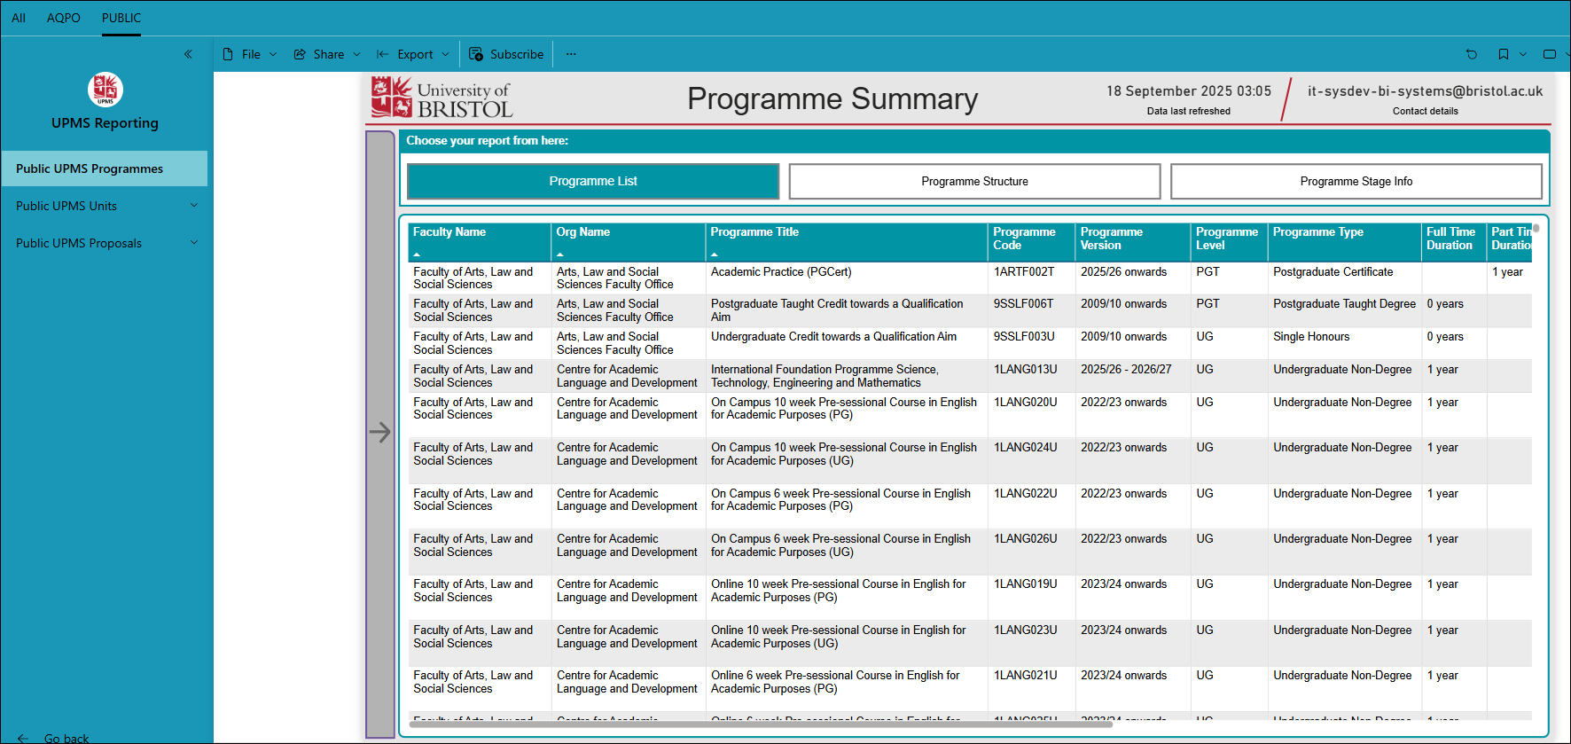

**LEFT NAVIGATION BAR**

Lists the Power BI reports with a dropdown list of report pages.

**MAIN CONTENT AREA**

Shows the report output (with page header, bookmarks, slicers, and visuals).

### Viewing an individual Power BI Report

Open the Power BI report from the Power BI workspace, as described above, and the report output is composed of two main areas:

## Viewing an individual Power BI Report

Open the Power BI report from the Power BI workspace, as described above.

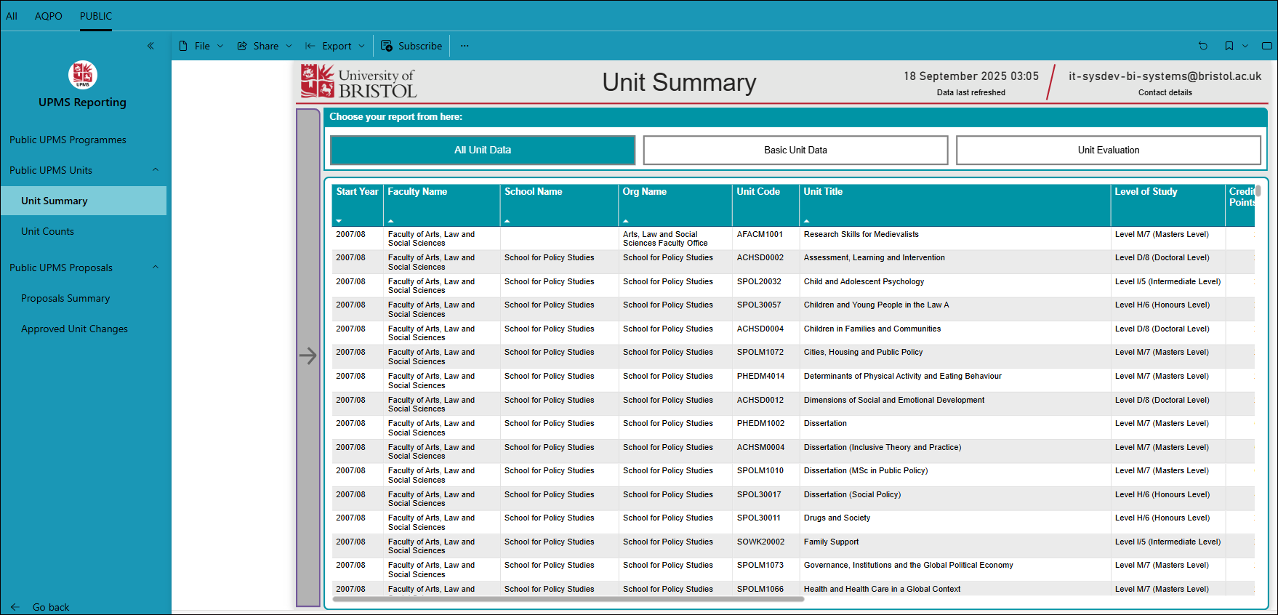

In the Main Content Area, you will sometimes see a clickable slicer panel or report bookmarks. Due to the complexity of some reports, not all report pages have report bookmarks, or the slicer panel.

Please use these as follows:

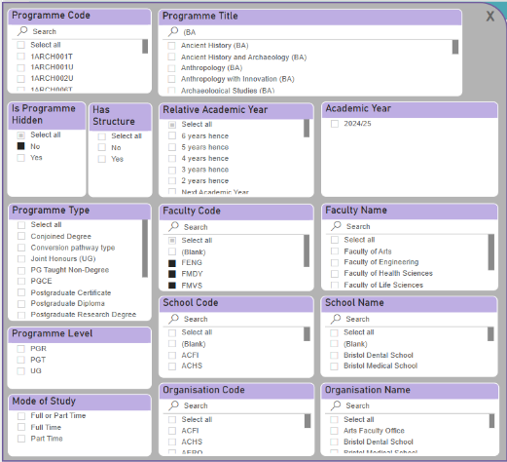

*Slicer panel example*

* Click a report bookmark to display the type of report (e.g. basic unit data) – this will reset the report slicers and recalculate the report visuals.
* Click the slicer panel to show the set of available slicers for this report page, and change the slicer options, as appropriate, to modify the report output.

The default year is always the current academic year

To exit the slicer panel click outside the panel, or click the “X” button to close.

Some reports also have filters at the top of the report

## Exporting data from a Power BI Report

Once you have selected the relevant data using the report bookmarks and/or slicer you can export your data to Excel by:

Clicking on the three dots that appear when you hover at the top right of the main section of the report (see below)

From the drop down menu that appears select “Export data” then “Data with current layout” then the green “Export” button. You will see an excel spreadsheet appear in your downloads. This can then be filtered and sorted.